02.06 requirements work scoping
Process Design & AMOS Configuration Document
Revision
Author, Name | Date | Notes

Purpose
This Process Design document is provided to Key-Users to record their key decisions regarding the AMOS Process design and the required AMOS configuration.
It is updated throughout the Project Definition Phase and used as the baseline for the Final Acceptance prior to Go-Live

Table of Contents
1. Process Overview & Objectives 3
2. Regulatory References 4
3. Definitions & Glossary 4
4. Process Tasks 4
5. Process Dependencies 5
6. Process Flow 6
7. Process Design Questions 7
8. Data (Source) Mapping 8
9. Other Software Used 8
10. AMOS Configuration 9
a. Basic Data 9
b. Parameters 9
c. Workflows 9
d. Scheduled Tasks 10
e. API’s & Interfaces 10
11. Annex – Additional Info 11

Process Overview & Objectives

Process General Description:
This process is usually executed by the Engineering department of an Airline or a CAMO services provider.
The requirements work scoping process is a requirement to then be able to properly define maintenance events in AMOS. This process is continuously executed as it is run both at the initial creation of the work scope and at its revision.
The trigger for this process is the need to create or modify a work template for maintenance planning, and the output of this process is a work scope for planning purposes.
The main benefits identified for the organisation when fully adopting this process are the following:
- Process improvement: If the work scopes are accurate, the maintenance planning and preparation will be properly driven to the best standards.
- Internal management: With accurate work scopes, the manpower both in engineering and maintenance will be optimized as this will reduce the interactions generated by unclear or incomplete information during the work scope assignment.
- The work template authoring policy inside the organisation should clearly specify which department is responsible of which work template elements. Nevertheless, it is important to emphasize that although the CAMO is responsible to determine when a maintenance event is supposed to be performed, the MRO is the entity that has the required expertise to determine how the maintenance event should be planned and executed.

Main Process Objective (Outputs & Outcomes):
The main stake holder involved in this process is the Engineering department. This department is usually responsible for defining the work scoping and updating them when required.
- It is CAMO/Engineering department is responsible got the creation and initialisation of an AMP event creates a basic requirement work scope that is associated to the event.
- Maintaining the requirement work scoping is an on-going process that requires continuous involvement of engineering departments while managing Maintenance Programs and documents revisions.
- Production Engineering/Planning is also usually the department that translates the requirement work scoping into productive work instructions. Work template creation and authoring is usually performed by users that have maintenance planning and maintenance execution experience. This allows them to efficiently create accurate templates that can easily be used in productive environments.
- The validation of the work templates after their creation may involve different level of users within the Production Engineering/Planning department.

Regulatory References

The main benefits regulatory references identified for this process are the following:
- EASA Part-M – M.A.401 – Maintenance Data
- EASA Part-M – M.A.402 – Performance of Maintenance

Definitions & Glossary

Key-Words | Explanation
Work Template | Work instructions which are saved as template. Main use case is the usage for scheduled maintenance events but there are also possibilities and use cases to use pre-defined templates for unscheduled maintenance.
Task Card | Maintenance Event on maintenance forecast which is triggered by maintenance program requirement - this task card can be standalone on maintenance forecast and/or integrated in check
Replacement Event | A Replacement Event is created in AMOS for each rotable, that has at least one requirement defined, which triggers the replacement of the component - rotable requirement or component document
Workpackage | The workpackage is the container for various maintenance events. Unscheduled and scheduled maintenance event can be included. Workpackages are handed over to the MRO to clearly define the scope of work.

Process Tasks

Main Process Task / Actions / Activities:
The following actions are performed in this Business Process:
- From the MPD: Define task Effectivities, Time Requirements, Restrictions, References, work scope. Create checks and internal checks as necessary. Define for them their own Effectivity framework, restrictions, time requirements and work scope.
- From Technical Publications: Create Modifications issued from Documents specifying Type, Effectivities, Time Requirements, Restrictions, References, work scope.
- From Part Requirements: Create on wing part requirements or replacement events specifying Type, Effectivities, Time Requirements, Restrictions, References, work scope.

Process Dependencies

- 03.01 – Planning: The process covers the management and control of the continuous airworthiness of the fleet, including constituent assemblies and components, through the planning of maintenance layovers in which to perform the maintenance tasks due. Main drivers for the generation of maintenance layovers are the aircraft availability for maintenance (available slots), the maintenance requirements due dates and their interval's utilisation.

Process Flow
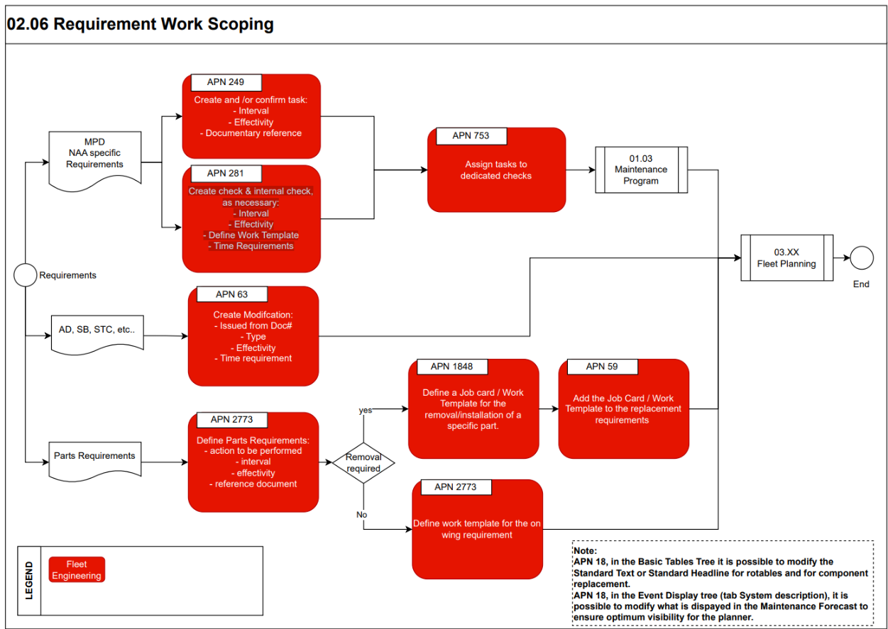
This flow chart is based on three different main paths:
- MPD and NAA specific requirements
- Technical Publications
- Part Requirements

Process Design Questions

# | Question | Answer
1 | How do release technical publications to engineering department?
2 | Do you have standardized requirements work scoping?
3 | Do you have a revisioning process in place?
4 | Who is responsible to generate the corresponding work instructions?

Data (Source) Mapping

Data Sources | Description | Volume / Manual / Automatic / Static / Dynamic
-Nil-

Other Software Used

Other Softwares | Used by: | Description
-Nil-

AMOS Configuration

The AMOS Configuration with regards to this process is extensive especially on the basic data setup aspect.

Basic Data

Basic Data Table | Notes
Planning Qualifications | To define Skill and Scope by staff specialty or qualification in order to match OEMs documents.  Skill e.g. : C, B1, B2 etc...  Scope : Mech., EIR, Cabin,
Meta Data Key | Basic Table to define the applicable meta keys which can be used when defining new meta data.  If a `Mime type` is added the user is able to choose the meta data value via book when adding a value
Standard Text | Defines replacements for the @STANDARD_TEXT@ and @STANDARD_HEADLINE@ wildcards of a work template.

Parameters

Parameter Code | Parameter Name | Notes | Settings
1878 | Work Step Wildcards Behaviour | This parameter allows the wildcard feature to be enabled or not and determines the behaviour of the wildcards in the work templates. | Float: 1.00  Integer: 0  String: “”

Workflows

Workflow Number | Workflow Name | Notes
230 | Work Template Modification | The workflow will be triggered whenever a Work Template is modified. The following actions are possible: CHANGED, DELETED or NEW (for each action a Template Rule exists). To differentiate between the Work Template Requirement References the wildcard “event_type” can be used.
390 | Work template Update Revision | The workflow will be triggered when 'Update Revision' function is performed. To differentiate between the Work Template Requirement References the wildcard “event_type” can be used.

Scheduled Tasks

Scheduled Task Reference | Frequency | Notes
WorkTemplateActivateRevisionService | As required

API’s & Interfaces

Reference | Direction | Trigger | Frequency
Transfer work template | Exchange work template data between two AMOS systems or with other systems – Import & Export
Export work template meta data grouping | Export work template meta data grouping from the AMOS environment - Export only

Annex – Additional Info

-Nil-

